Client area:

This area specialize for clients users to control their trades and MT users and their agent area.

Features :

1. Control MT users and their trades .
2. Manage and analyses commissions and money for user.
3. Apply MT requests directly .
4. Use FXWEBKIT tools.

Sections :

Dashboard:

Client dashboard contain analyses for MT users trades and some statistics for MT users and their trades .

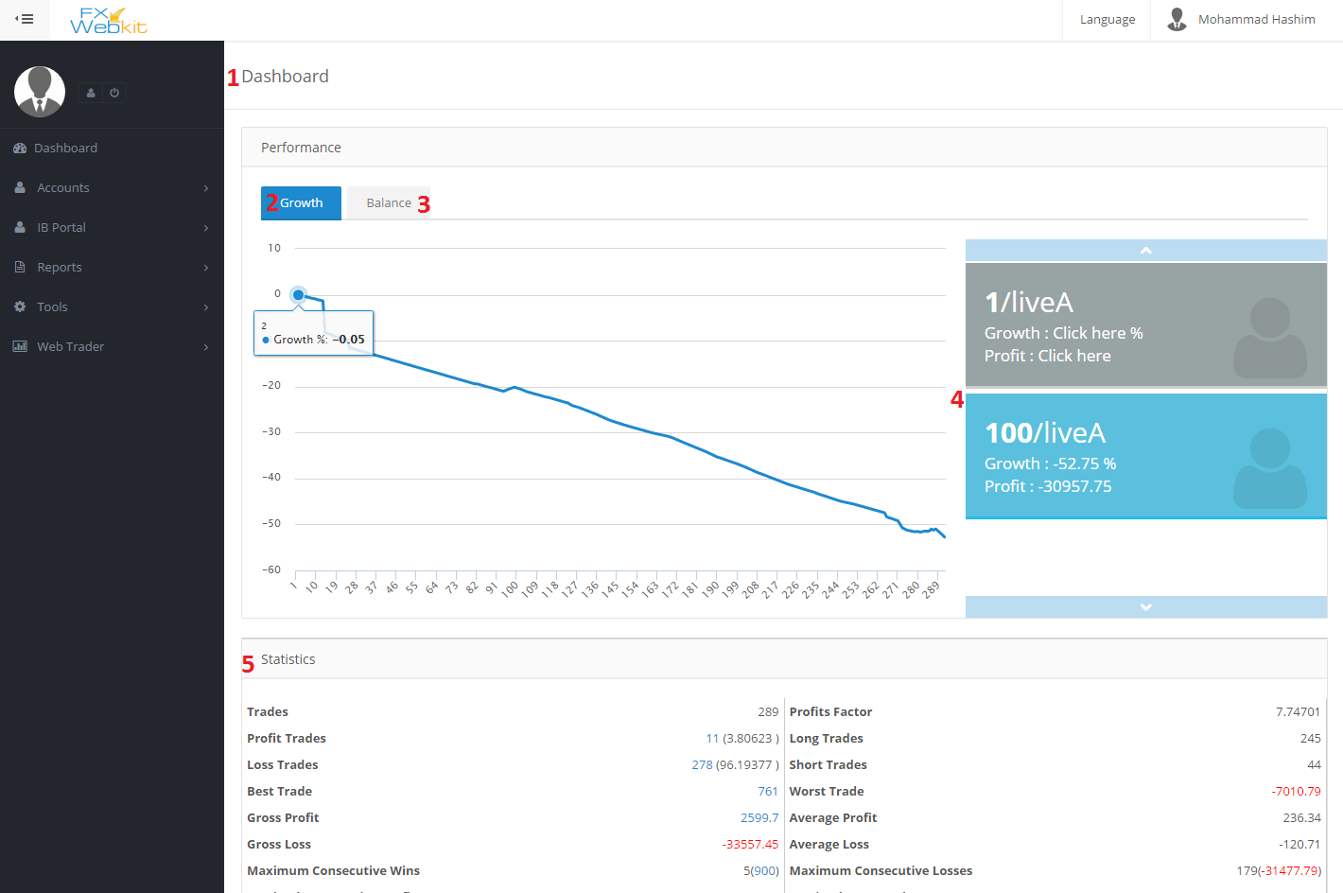

1. Client Dashboard : the main page for client to help him analyze his trades with his MT users.
2. Growth Chart : to see each MT user growth chart just click on the MT user at the left side.
3. Balance Chart : this tab to see balance chart for the selected MT user
4. MT user list : all MT users whose assigned to this client .
5. Statistics : those statistics for the selected MT user’s trades.

Accounts:

This module to manage MT users for this client and apply some activities on them with requests to the MT server.

Add MT user :

For each client on FXWEBKIT software there are number of MT users those MT users can be added through client himself by this page if the admin allow direct order for MT server the request will be auto go to the server otherwise the request will go to the admin and the admin decide .

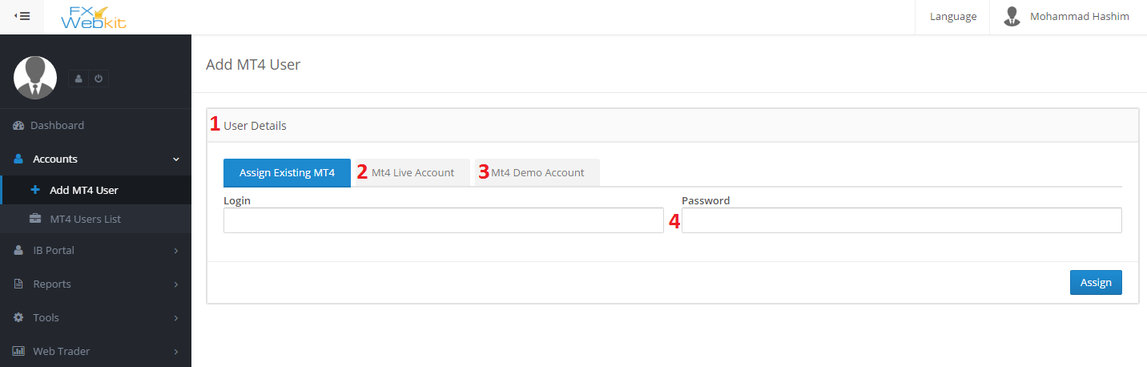

1. MT user details : type the login and the password for existing MT user in MT server and assign him to this client .
2. Create New MT Live user : if the client want to create new MT user which is not exist on the MT server he has to go to this tab insert new MT user and click add if the admin allow direct order for MT server the request will be auto go to the server and the result ( if success ) the new MT user will be assigned to this client.
3. Create Demo MT user : same thing with alive but this request go to the demo MT server.
4. MT user Password : this will be optional if the admin request it from admin public settings .

MT Users List :

All the MT users whose assigned to the client from the admin or by add MT user tab will be listed here so the client can see them and apply some MT server requests

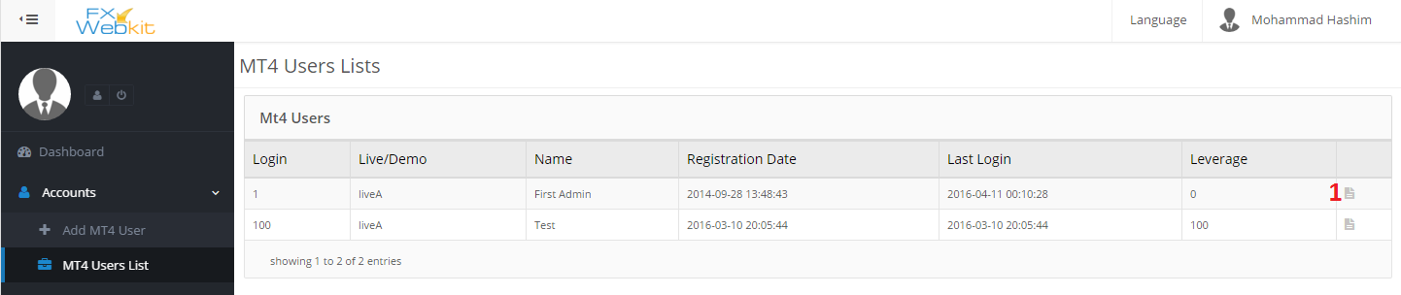

1. MT user details : details for the MT user and apply some action on this MT user like change password , change leverage and transfer but all those actions can be hidden from admin side.

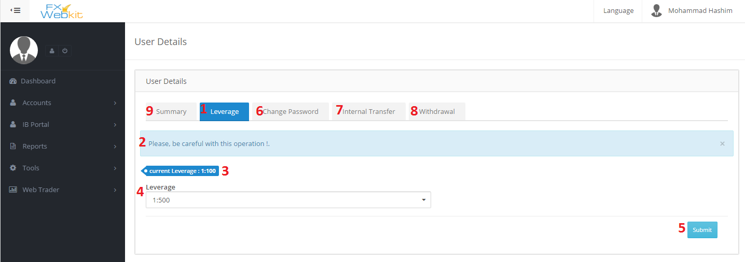

1. Leverage : to change the current leverage for selected MT user.
2. Warning Message : this message from admin settings to warn user if he want change the leverage.
3. Current leverage : leverage for selected MT user.
4. Select leverage : list all leverages will be listed but the current leverage.
5. Submit : apply new changes but if the admin does not choose to direct request to the MT server option the request will be sent to the admin first and the admin decide.
6. Change MT user password : to change current password to new password for selected MT user.
7. Internal Transfer : transfer money from this MT user to another one depend on admin settings the client can transfer money from this MT user to any MT user or just for his (client) MT users.
8. Withdrawal : withdrawal from this MT user account.
9. Summary : MT details and info.

IB Portal :

We have talk about this module in the admin area here is the same thing but for one client and his users.

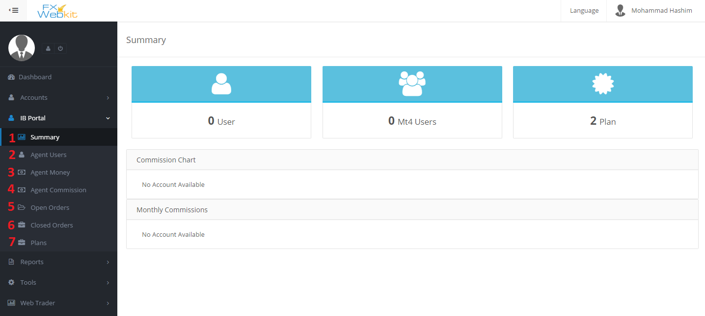

1. Summary : some info about the agent and his users with commission .
2. Agent Users : the users whose register in the FXWEBKIT system through this Client .
3. Agent Money : the money of this client which he get depend on his agent’s users .
4. Agent commission : the commission from the trades of agent’s users MT users.
5. Open Orders : all agent’s users MT users open trades orders listed here with filtration.
6. Closed Orders : all agent’s users MT users closed trades orders listed here with filtration.
7. Plans : list of plans that the admin assigned to this client.

Reports:

We have talk about this module in the admin area here is the same thing but for one client and his users.

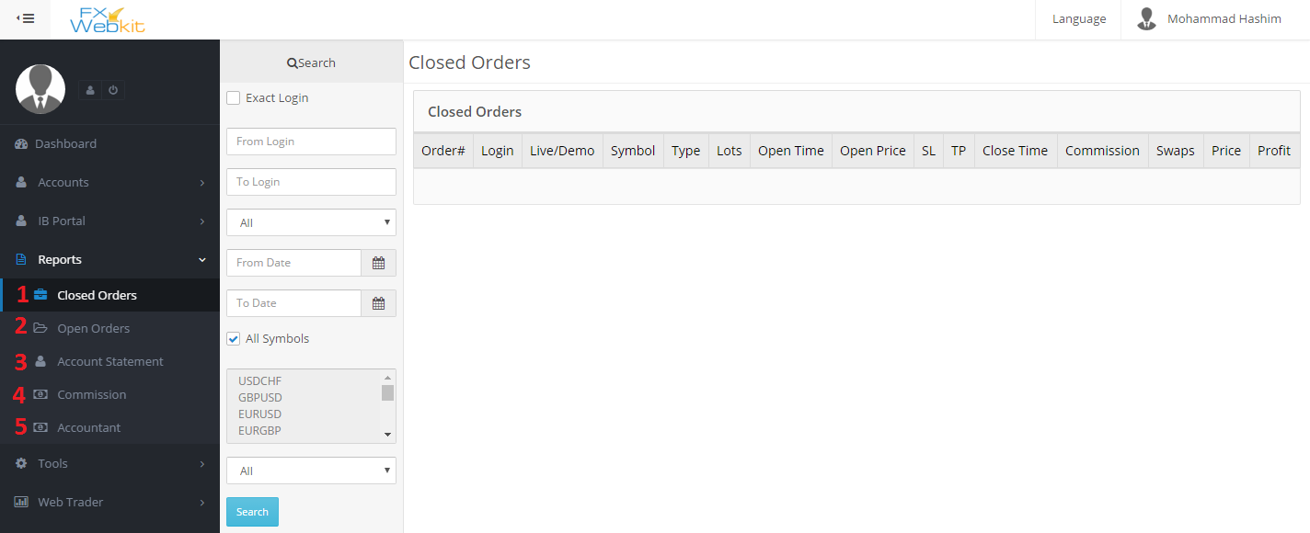

1. Closed Orders : list of Closed trade orders of MT users of this client.
2. Open Orders : list of open trade orders of MT users of this client.
3. Account statement of MT users of this client.
4. Commissions : commission of client’s MT users .
5. Accountant : accountant of client’s MT users .

Tools:

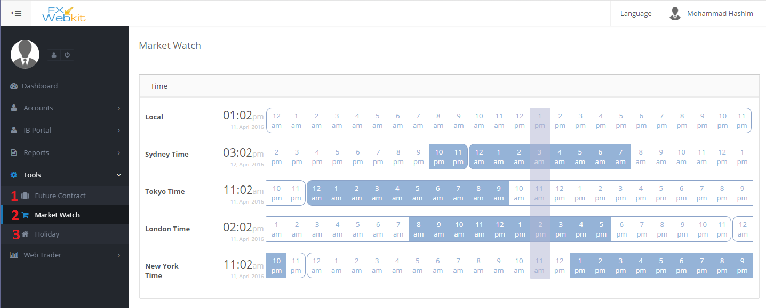

1. Future Contract: list of future contract and filtrations for the list.
2. Market Watch : trades Markets open hours .
3. Holiday : list of holidays and their details.

Web trader:

Web trader allow you to trade through the web site just insert MT user info and feel free to trade as you want

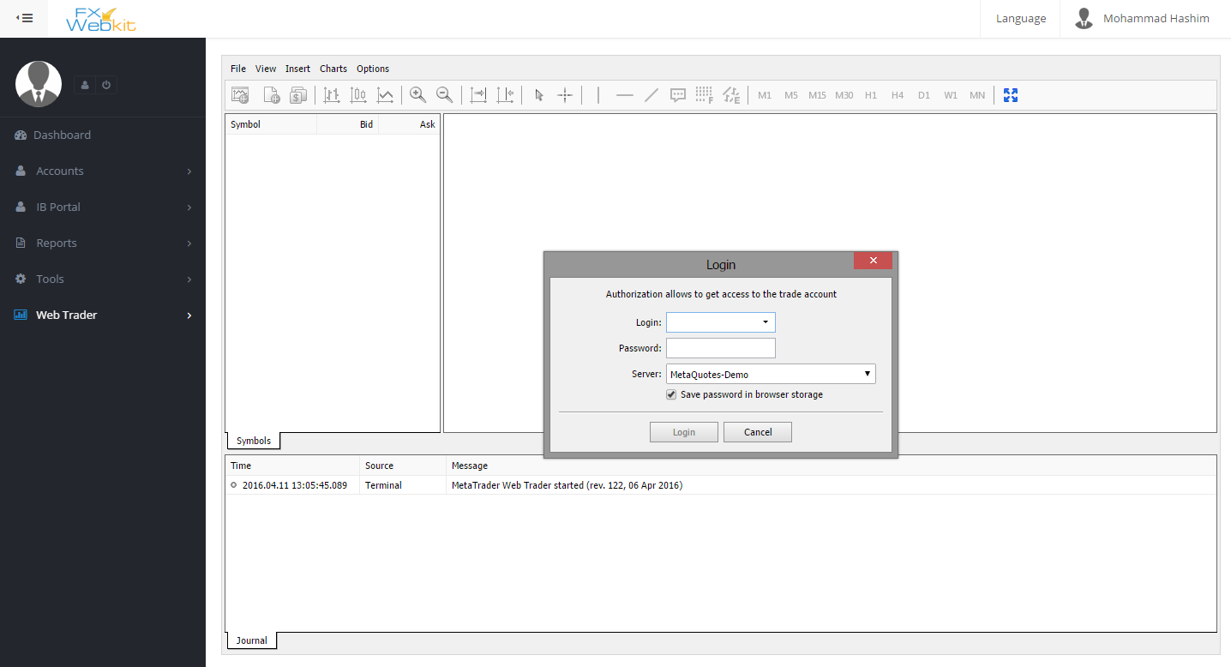

This link(web trader) can be hidden from admin settings.